**BookMyShow DataModelling Assignment**

Bookmyshow is a ticketing platform where you can book tickets for a movie show. The image attached represents that for a given theatre we can see the next 7 dates. As one chooses the date, we get list of all shows running in that theatre along with the show timings.

P1 - List down all the entities, their attributes and the table structures for the scenario mentioned in the previous slide. You also need to write the SQL queries required to create these tables along with few sample entries. Ensure the tables follow 1NF, 2NF, 3NF and BCNF rules.

P2 - Write a query to list down all the shows on a given date at a given theatre along with their respective show timings.

……………………………………………………………………………………………

P1: Entities, Attributes, and Table Structures

Entity Type – Movie Ticketing Platform

Entity Value – Movie, Theatre , Screens, Show, Seat

Attributes –

Theatre – Theatre_ID (Primary Key) , Theatre_Name, Location

Movie – Movie_ID(Primary Key), movie_name, total_time, Genres, Language, movie_ratings

Screens – Screen_ID(Primary Key), screen_name

Show – Show_ID (Primary Key), show_date , show_time

………………………..

**SQL QUERY: [ Create, Insert, Update, Drop ] – with No relationship**

**Movie Table**

**# -- Create movie table**

**CREATE TABLE Movie (**

**movie_id INT NOT NULL AUTO_INCREMENT,**

**movie_name VARCHAR(50) NOT NULL,**

**total_time TIME,**

**Genres VARCHAR(50),**

**language VARCHAR(50),**

**movie_ratings VARCHAR(50),**

**PRIMARY KEY(movie_id)**

**);**

**# -- Insert values into the movie table---**

**INSERT INTO Movie (Movie_ID, movie_name, total_time, Genres, Language, movie_ratings)**

**VALUES**

**(1234, 'DASARA', '01:30', 'CRIME', 'HINDI', 'U/A'),**

**(2345, 'KKBKKJ', '02:30', 'DRAMA', 'HINDI', 'U/A'),**

**(3456, 'TJMM', '02:30', 'SCIENTIFIC', 'HINDI', 'U/A'),**

**(4567, 'AVATAR', '02:30', 'DRAMA', 'ENGLISH', 'S');**

**# -- Update**

UPDATE Movie

set movie_ratings = U

WHERE **Movie_ID** = **2345**;

**#-- View the table**

select * from Movie

**#-- Delete Table**

DROP TABLE Movie

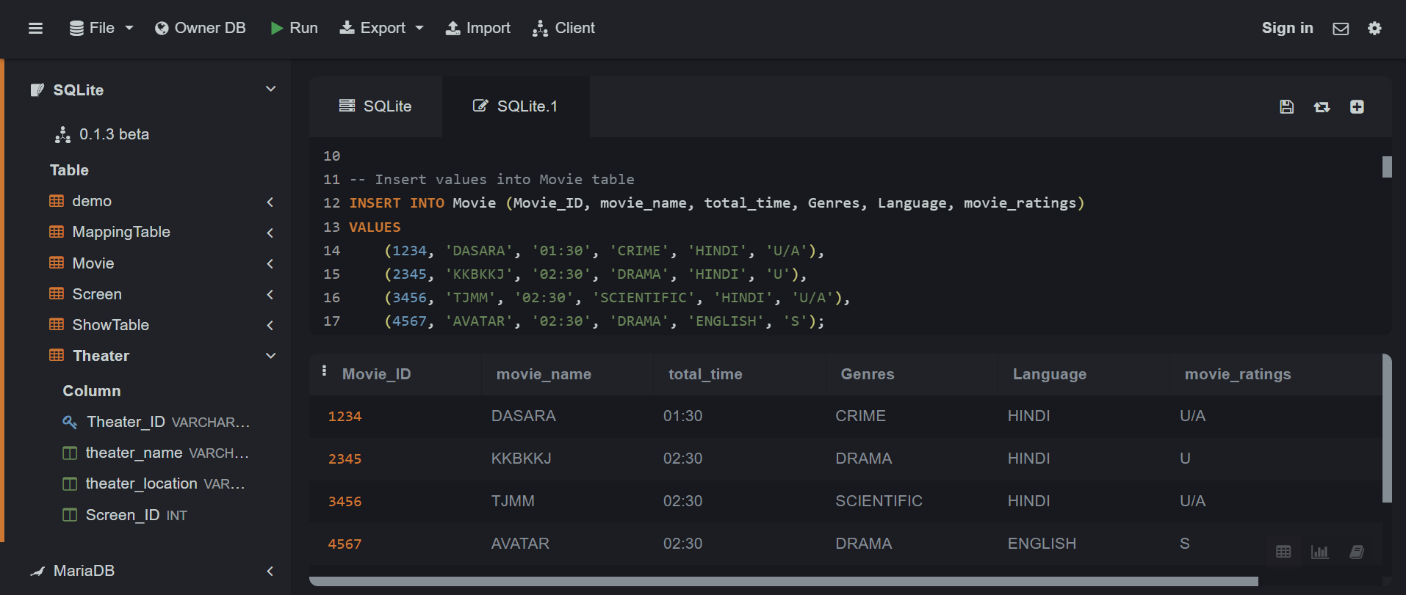

**................................................**

**Theatre Table**

**# -- Create Theatre table**

**CREATE TABLE Theatre (**

**Theatre_ID VARCHAR(10) NOT NULL,**

**Theatre_name VARCHAR(255) NOT NULL,**

**Location VARCHAR(255) NOT NULL,**

**PRIMARY KEY(Theater_ID)**

**);**

**#-- Insert values into the Theatre table**

**INSERT INTO Theatre (Theatre_ID, Theatre_name, Theatre_location)**

**VALUES**

**('101_201', 'PVR_NEXUS', 'Bangalore'),**

**('101_202', 'PVR_NEXUS', 'Bangalore'),**

**('101_203', 'PVR_NEXUS', 'Bangalore'),**

**('101_204', 'PVR_NEXUS', 'Bangalore');**

**# - VIEW**

select * from Theater

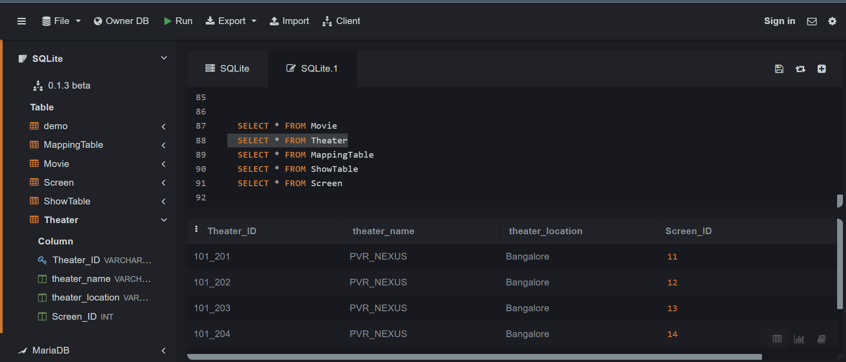

**..................**

**Show Table**

**# -- Create Show table**

**CREATE TABLE Show (**

**Show_ID INT NOT NULL PRIMARY KEY,**

**Show_date VARCHAR(100),**

**Show_Time VARCHAR(50)**

**);**

**#-- Insert values into the Show table**

**INSERT INTO Show (Show_ID, Show_date, Show_Time)**

**VALUES**

**(1, '25.4.23, 19.03.23, 20.03.23', '12:16 PM'),**

**(2, '25.4.23, 19.03.23, 20.03.23', '4:10 PM, 8:20 PM'),**

**(3, '25.4.23, 19.03.23, 20.03.23', '01:16 PM'),**

**(4, '25.4.23, 19.03.23, 20.03.23', '01:20 PM');**

**#--**  VIEW

select * from Show

**....................................**

**Screen Table**

**#-- Create Screen table**

**CREATE TABLE Screen (**

**Screen_ID INT PRIMARY KEY,**

**Screen_name VARCHAR(50)**

**);**

**#-- Insert values into the Screen table**

**INSERT INTO Screen (Screen_ID, Screen_name)**

**VALUES**

**(11, '2D'),**

**(12, '2D'),**

**(13, '2D'),**

**(14, '4D');**

**…………………………………………………………………………….**

Ensure the tables follow 1NF, 2NF, 3NF and BCNF rules.

**P1 – WITH relationship**

P1 SQL queries required to create BookMyShow tables along with few sample entries.

-- Create Movie table

CREATE TABLE Movie (

Movie_ID INT PRIMARY KEY,

Movie_name VARCHAR(255) NOT NULL,

Total_time TIME NOT NULL,

Genres VARCHAR(50) NOT NULL,

Language VARCHAR(50) NOT NULL,

Movie_ratings VARCHAR(5) NOT NULL

);

-- Insert values into Movie table

INSERT INTO Movie (Movie_ID, Movie_name, Total_time, Genres, Language, Movie_ratings)

VALUES

(1234, 'DASARA', '01:30', 'CRIME', 'HINDI', 'U/A'),

(2345, 'KKBKKJ', '02:30', 'DRAMA', 'HINDI', 'U'),

(3456, 'TJMM', '02:30', 'SCIENTIFIC', 'HINDI', 'U/A'),

(4567, 'AVATAR', '02:30', 'DRAMA', 'ENGLISH', 'S');

-- Create Theater table

CREATE TABLE Theater (

Theater_ID VARCHAR(10) PRIMARY KEY,

Theater_name VARCHAR(255) NOT NULL,

Theater_location VARCHAR(255) NOT NULL

);

-- Insert values into Theater table

INSERT INTO Theater (Theater_ID, Theater_name, Theater_location)

VALUES

('101_201', 'PVR_NEXUS', 'Bangalore'),

('101_202', 'PVR_NEXUS', 'Bangalore'),

('101_203', 'PVR_NEXUS', 'Bangalore'),

('101_204', 'PVR_NEXUS', 'Bangalore');

-- Create Show Table

CREATE TABLE ShowTable (

Show_ID INT PRIMARY KEY,

Show_date DATE NOT NULL,

Show_Time TIME NOT NULL,

Movie_ID INT NOT NULL,

Theater_ID VARCHAR(10),

FOREIGN KEY (Movie_ID) REFERENCES Movie(Movie_ID),

FOREIGN KEY (Theater_ID) REFERENCES Theater(Theater_ID)

);

-- Insert values into Show Table

INSERT INTO ShowTable (Show_ID, Show_date, Show_Time, Movie_ID, Theater_ID)

VALUES

(1, '25.4.23, 19.03.23, 20.03.23', '12:16 PM', 1234, '101_201'),

(2, '25.4.23, 19.03.23, 20.03.23', '4:10 PM, 8:20 PM', 2345, '101_202'),

(3, '25.4.23, 19.03.23, 20.03.23', '01:16 PM',3456, '101_203'),

(4, '25.4.23, 19.03.23, 20.03.23', '01:20 PM',4567,'101_204');

-- Create Screen Table

CREATE TABLE Screen (

Screen_ID INT PRIMARY KEY,

Screen_name VARCHAR(50) NOT NULL,

Show_ID INT,

FOREIGN KEY (Show_ID) REFERENCES ShowTable(Show_ID)

);

-- Insert values into Screen Table

INSERT INTO Screen (Screen_ID, Screen_name, Show_ID)

VALUES

(11, '2D', 1),

(12, '2D', 2),

(13, '2D', 3),

(14, '4D', 4);

-- View all the table

select * from Movie

select * from Theater

select * from ShowTable

select * from Screen

--P2 Query to list down all the shows on a given date at a given theatre along with their respective show timings.

SELECT

Movie.Movie_name AS MovieName,

Theater.Theater_name AS TheatreName,

ShowTable.Show_date AS ShowDate,

ShowTable.Show_Time AS ShowTime

FROM

ShowTable

JOIN

Movie ON ShowTable.Movie_ID = Movie.Movie_ID

JOIN

Theater ON ShowTable.Theater_ID = Theater.Theater_ID

WHERE

ShowTable.Show_date = '2023-04-25'

AND Theater.Theater_ID = '101_201';

//////////////////////////////////////////////////// BCNF////////////////////////

-- Create Movie table

CREATE TABLE Movie (

Movie_ID INT PRIMARY KEY,

movie_name VARCHAR(255) NOT NULL,

total_time TIME NOT NULL,

Genres VARCHAR(50) NOT NULL,

Language VARCHAR(50) NOT NULL,

movie_ratings VARCHAR(5) NOT NULL

);

-- Insert values into Movie table

INSERT INTO Movie (Movie_ID, movie_name, total_time, Genres, Language, movie_ratings)

VALUES

(1234, 'DASARA', '01:30', 'CRIME', 'HINDI', 'U/A'),

(2345, 'KKBKKJ', '02:30', 'DRAMA', 'HINDI', 'U'),

(3456, 'TJMM', '02:30', 'SCIENTIFIC', 'HINDI', 'U/A'),

(4567, 'AVATAR', '02:30', 'DRAMA', 'ENGLISH', 'S');

--VIEW

select * from Movie



/////////////////////////////////////////////////////////////////////////

-- Create Theater table

CREATE TABLE Theater (

Theater_ID VARCHAR(10) PRIMARY KEY,

theater_name VARCHAR(255) NOT NULL,

theater_location VARCHAR(255) NOT NULL,

Screen_ID INT,

FOREIGN KEY (Screen_ID) REFERENCES Screen(Screen_ID)

);

-- Insert values into Theater table

INSERT INTO Theater (Theater_ID, theater_name, theater_location, Screen_ID)

VALUES

('101_201', 'PVR_NEXUS', 'Bangalore', 11),

('101_202', 'PVR_NEXUS', 'Bangalore', 12),

('101_203', 'PVR_NEXUS', 'Bangalore', 13),

('101_204', 'PVR_NEXUS', 'Bangalore', 14);

--VIEW

select * from Theater



///////////////////////

-- Create MappingTable

CREATE TABLE MappingTable (

MT_ID INT PRIMARY KEY,

Movie_ID INT,

Theater_ID VARCHAR(10),

FOREIGN KEY (Movie_ID) REFERENCES Movie(Movie_ID),

FOREIGN KEY (Theater_ID) REFERENCES Theater(Theater_ID)

);

-- Insert values into MappingTable

INSERT INTO MappingTable (MT_ID, Movie_ID, Theater_ID)

VALUES

(10, 1234, '101_201'),

(20, 2345, '101_202'),

(30, 3456, '101_203'),

(40, 4567, '101_204');

**--VIEW**

select * from MappingTable

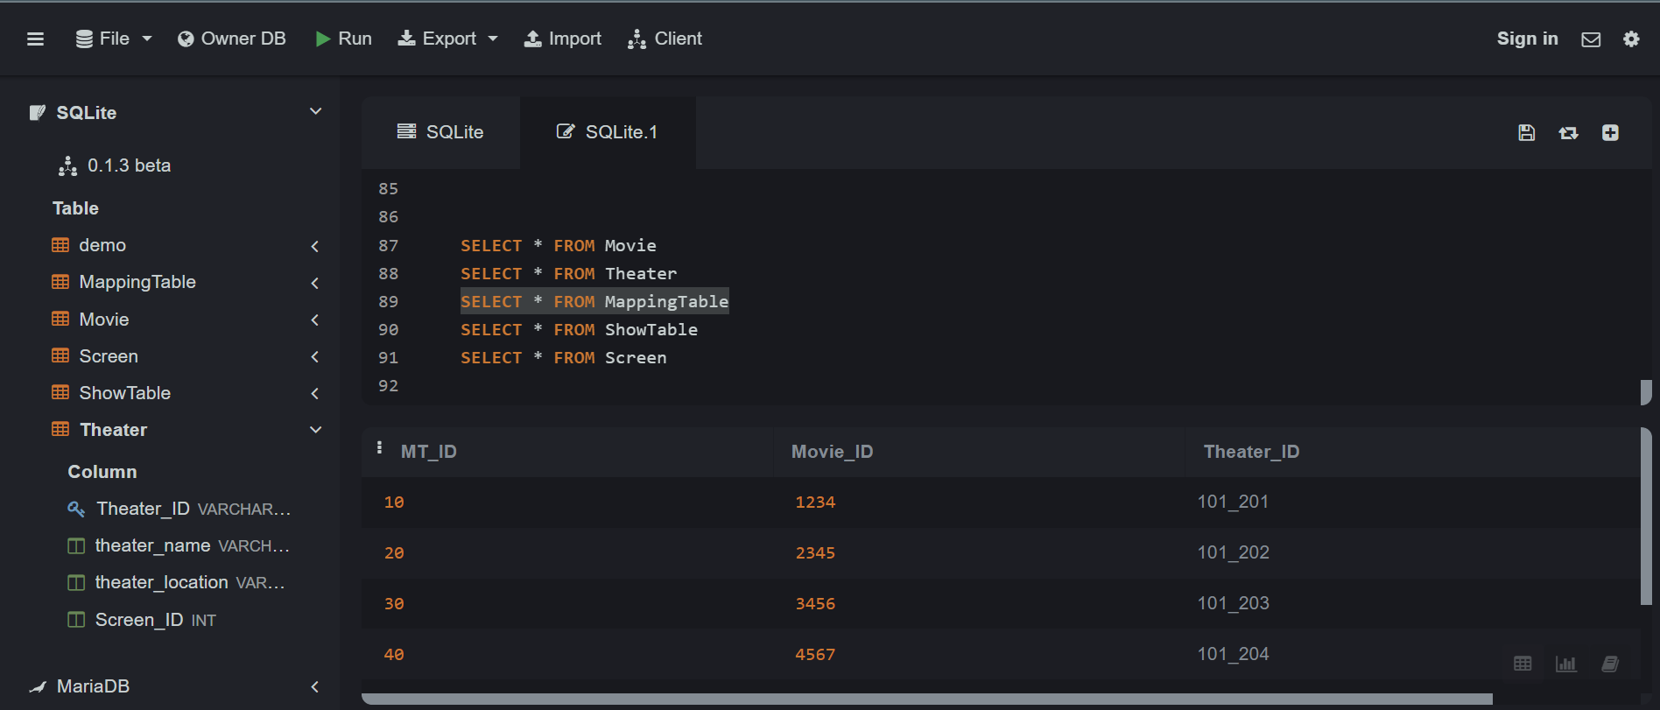

///////////////////////////////////

-- Create ShowTable

CREATE TABLE ShowTable (

Show_ID INT PRIMARY KEY,

Show_date DATE NOT NULL,

Show_Time TIME NOT NULL,

MT_ID INT,

FOREIGN KEY (MT_ID) REFERENCES MappingTable(MT_ID)

);

-- Insert values into ShowTable

INSERT INTO ShowTable (Show_ID, Show_date, Show_Time, MT_ID)

VALUES

**(1, '25.4.23, 19.03.23, 20.03.23', '12:16 PM', 10),**

**(2, '25.4.23, 19.03.23, 20.03.23', '4:10 PM, 8:20 PM', 20),**

**(3, '25.4.23, 19.03.23, 20.03.23', '01:16 PM', 30),**

**(4, '25.4.23, 19.03.23, 20.03.23', '01:20 PM', 40);**

* -- SHOW
* select * from ShowTable
* 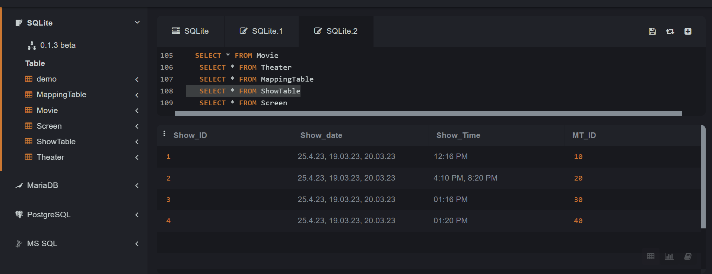

-- Create Screen table

CREATE TABLE Screen (

Screen_ID INT PRIMARY KEY,

Screen_name VARCHAR(50) NOT NULL,

Show_ID INT,

FOREIGN KEY (Show_ID) REFERENCES ShowTable(Show_ID)

);

-- Insert values into Screen table

INSERT INTO Screen (Screen_ID, Screen_name, Show_ID)

VALUES

(11, '2D', 1),

(12, '2D', 2),

(13, '2D', 3),

(14, '4D', 4);

**--VIEW**

select * from Screen

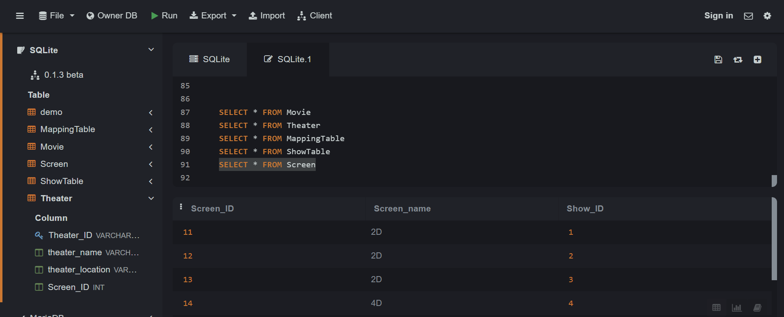

// P2 - Write a query to list down all the shows on a given date at a given theatre along with their respective show timings.

SELECT

Movie.movie_name AS MovieName,

Theater.theater_name AS TheatreName,

ShowTable.Show_date AS ShowDate,

ShowTable.Show_Time AS ShowTime

FROM

ShowTable

INNER JOIN

Movie_Show MS ON ShowTable.MT_ID = MS.Movie_ID

INNER JOIN

Movie_TheatreShow MTS ON MS.Movie_ID = MTS.Movie_ID

INNER JOIN

Theater T ON MTS.Theater_ID = T.Theater_ID

INNER JOIN

Movie M ON MS.Movie_ID = M.Movie_ID

WHERE

ShowTable.Show_Date = '25.4.23';